Quick-guide: leaf mines and plant galls

By Eric LoPresti and the HerbVar Insect Sampling Subgroup

**For all plants,** record the number of leaf mines and galls on the entire plant

For folks less familiar with leaf mines or plant galls, here is a quick visual guide.

Leaf mines

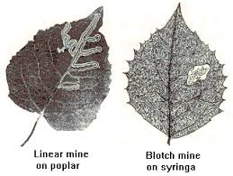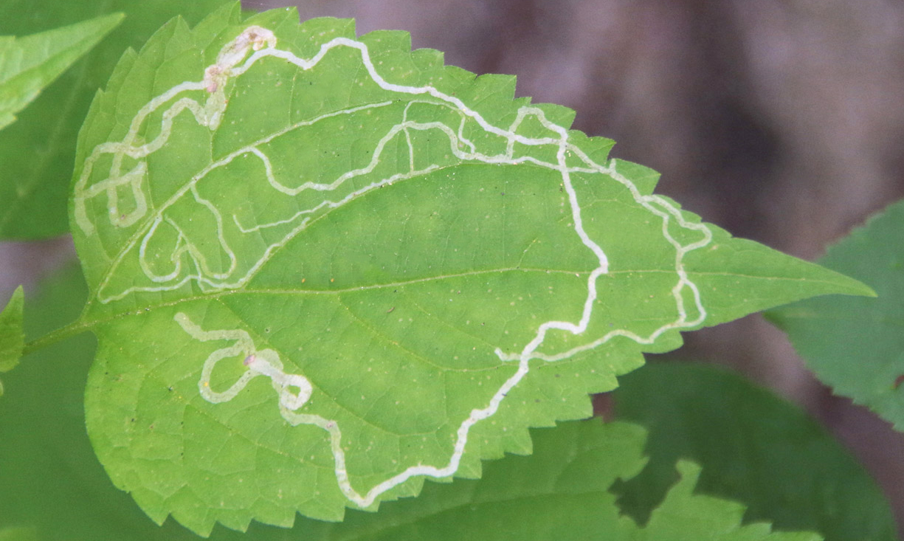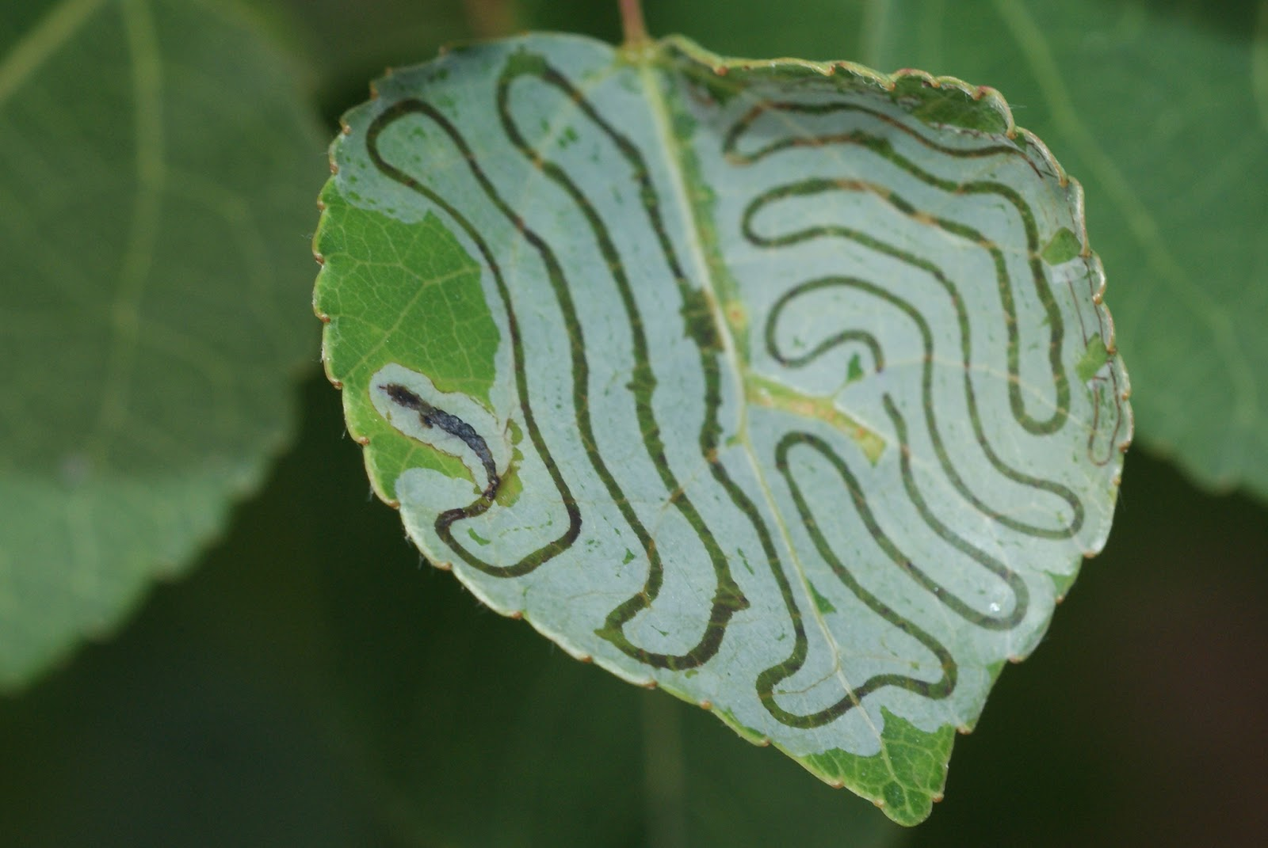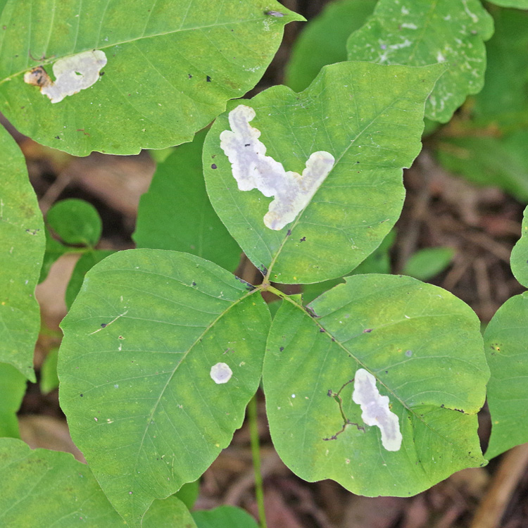 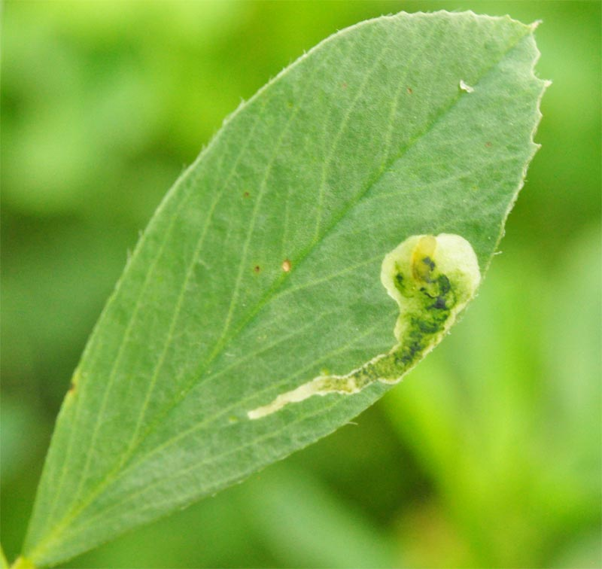 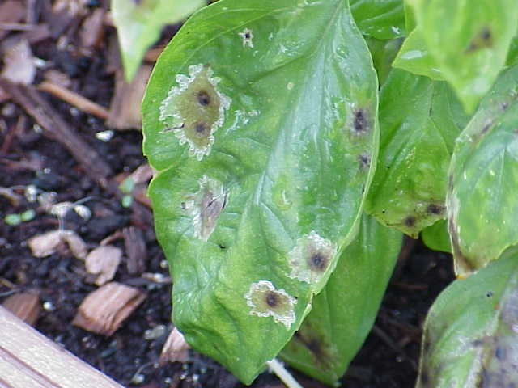 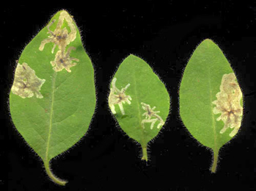

*Upper middle: multiple linear mines in a single leaf\**

*Below; several examples of multiple blotch mines on single leaves*

Galls

* Leaf

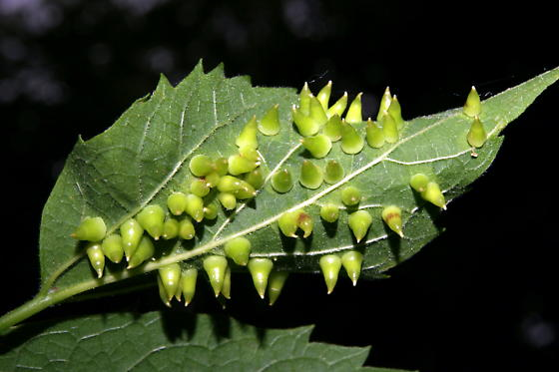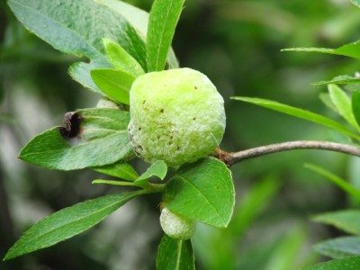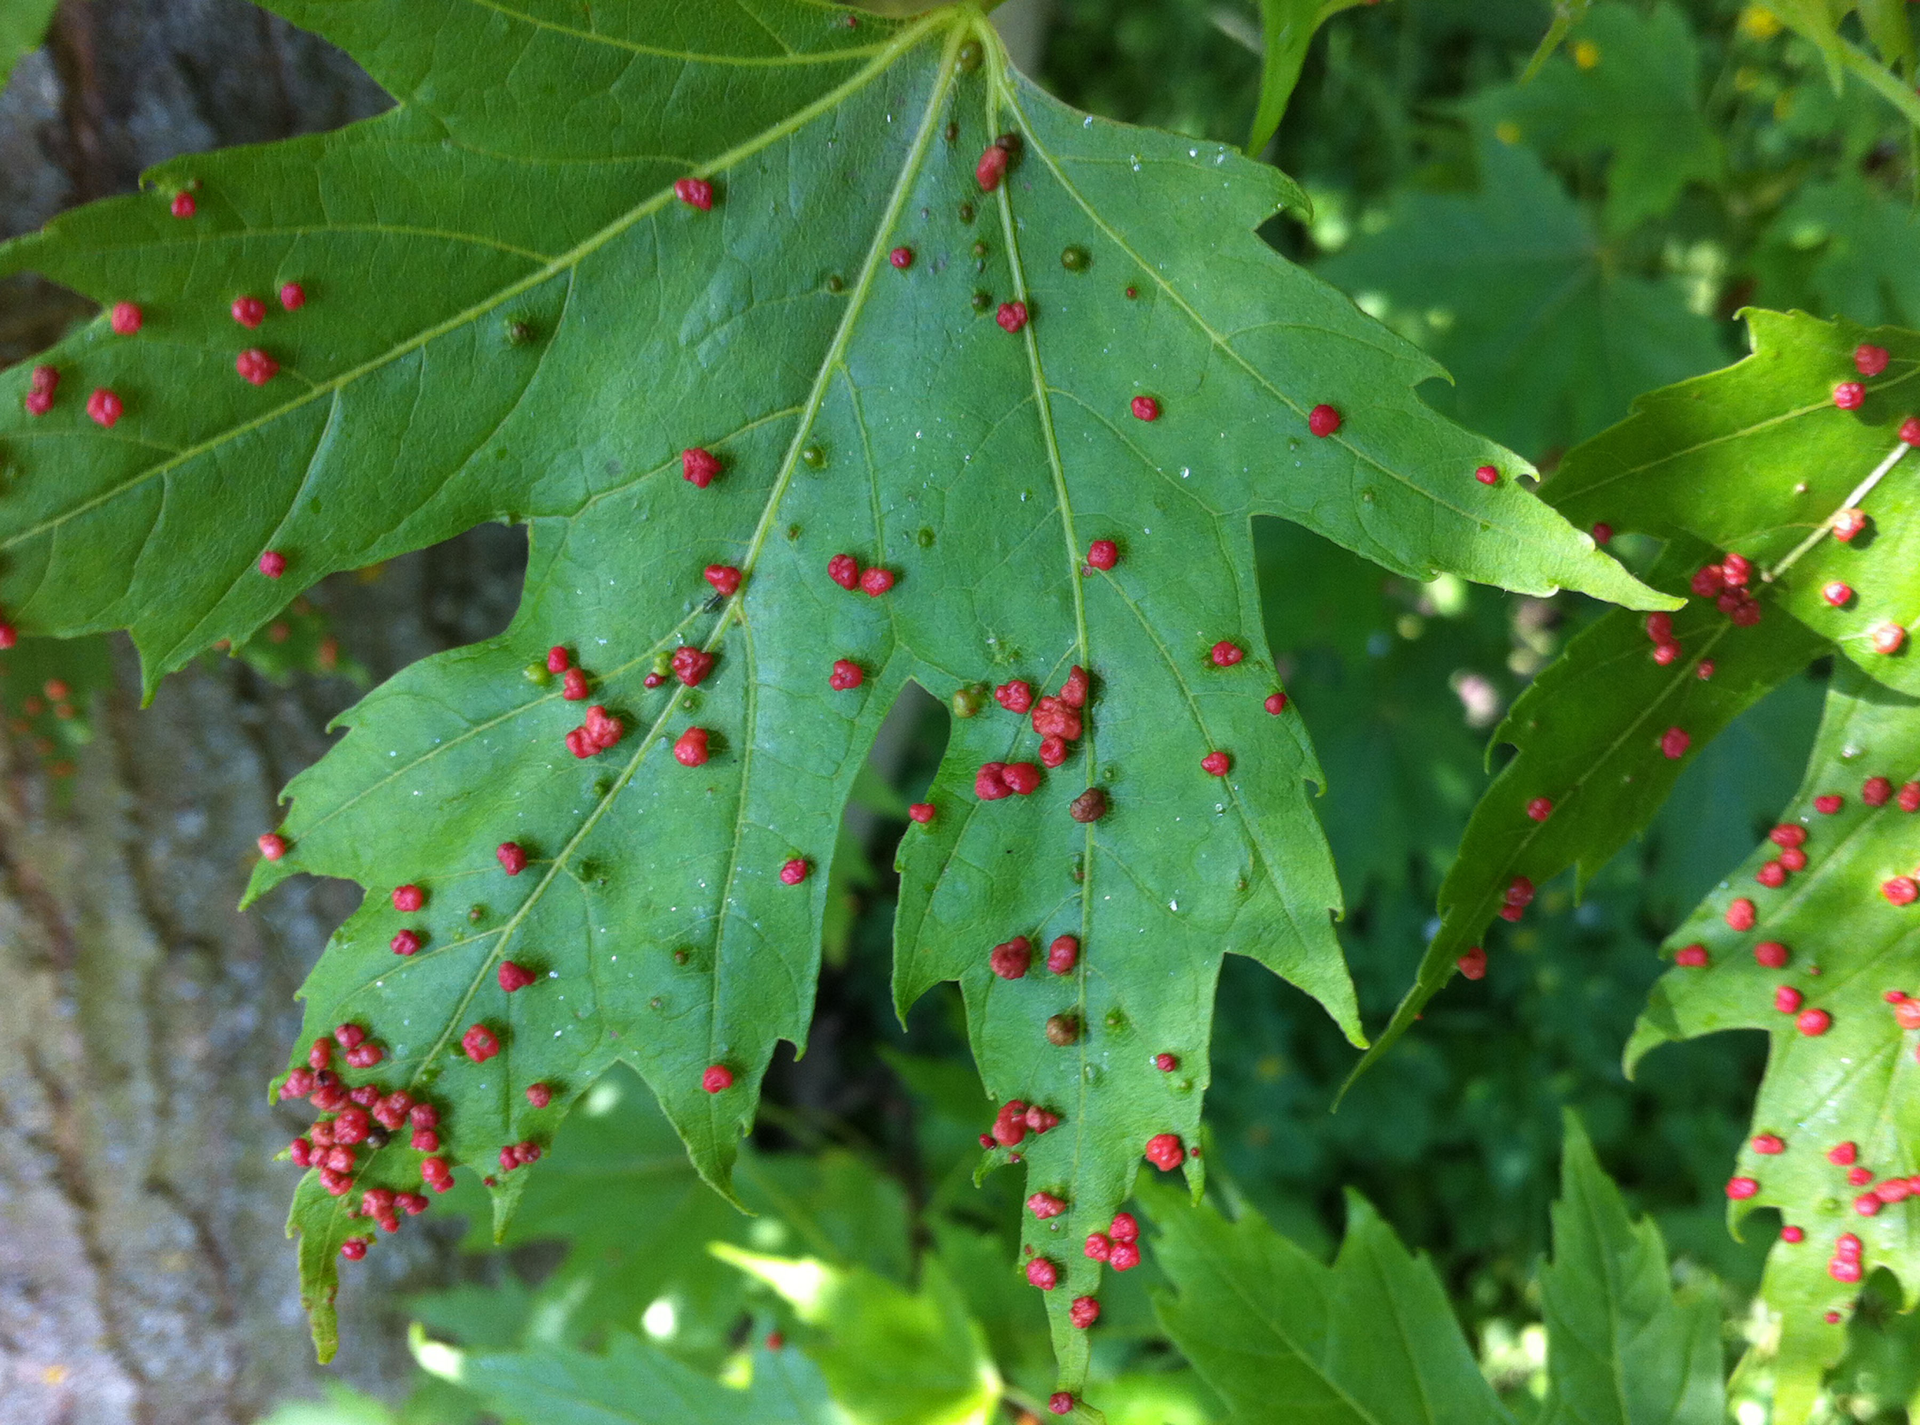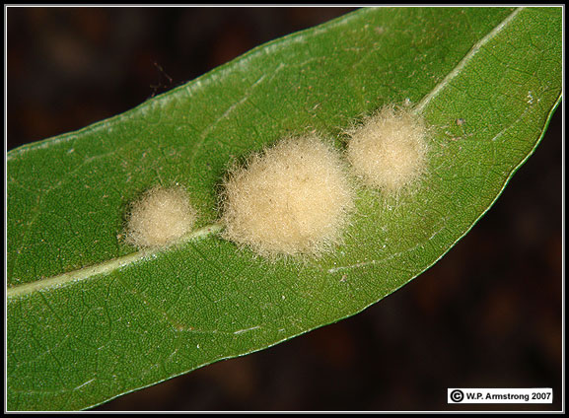

* Stem / branch

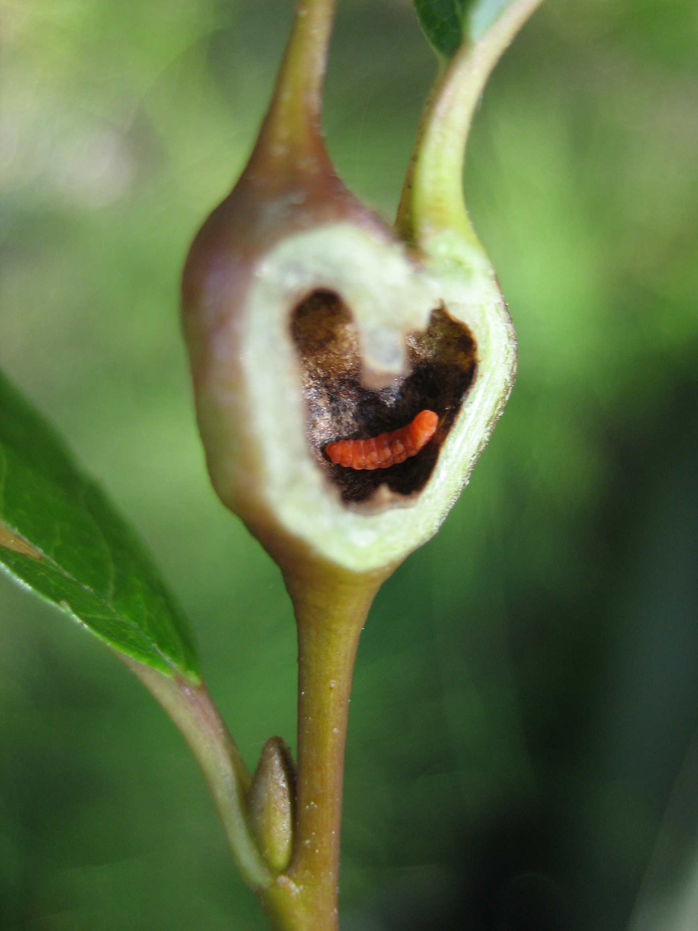 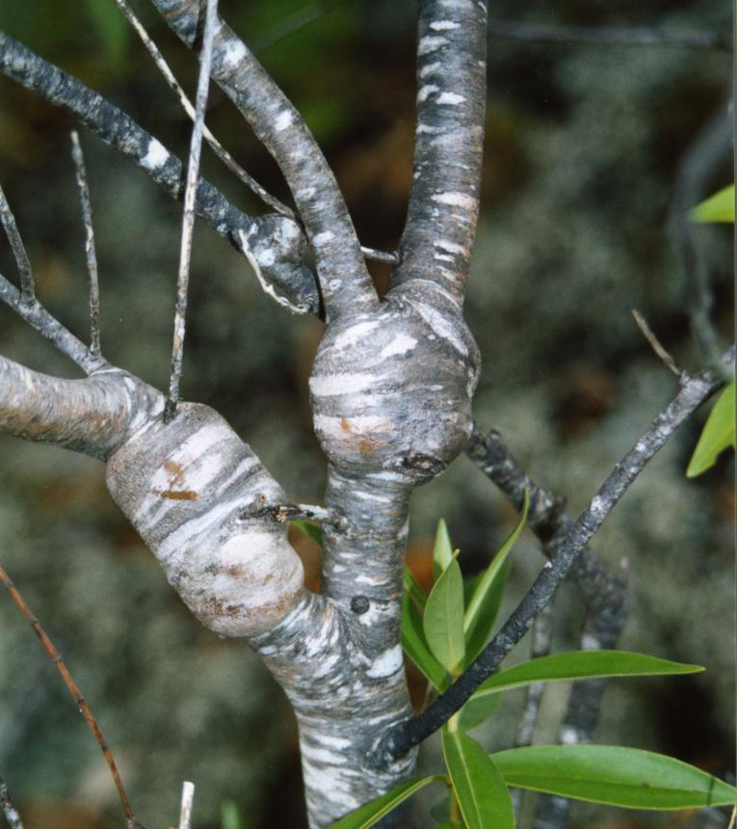 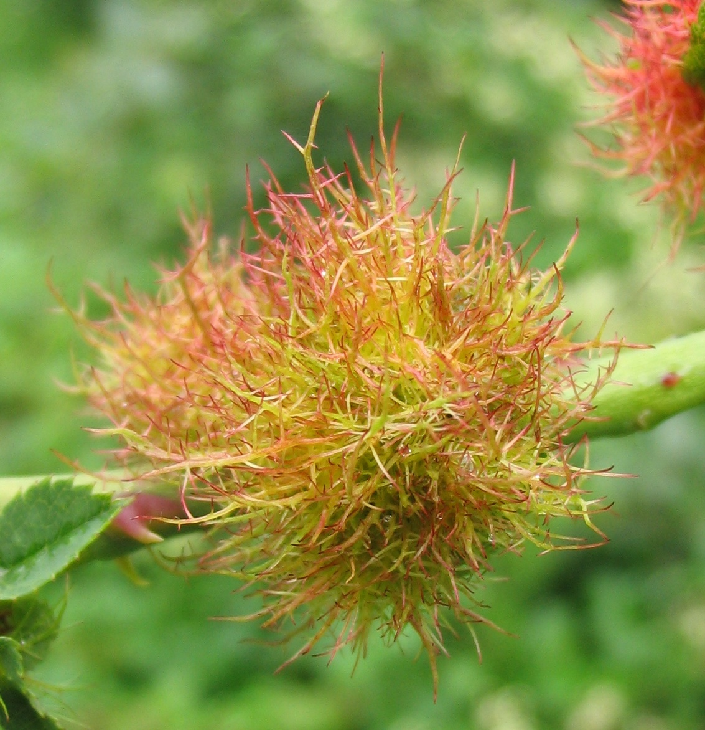 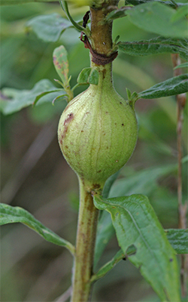 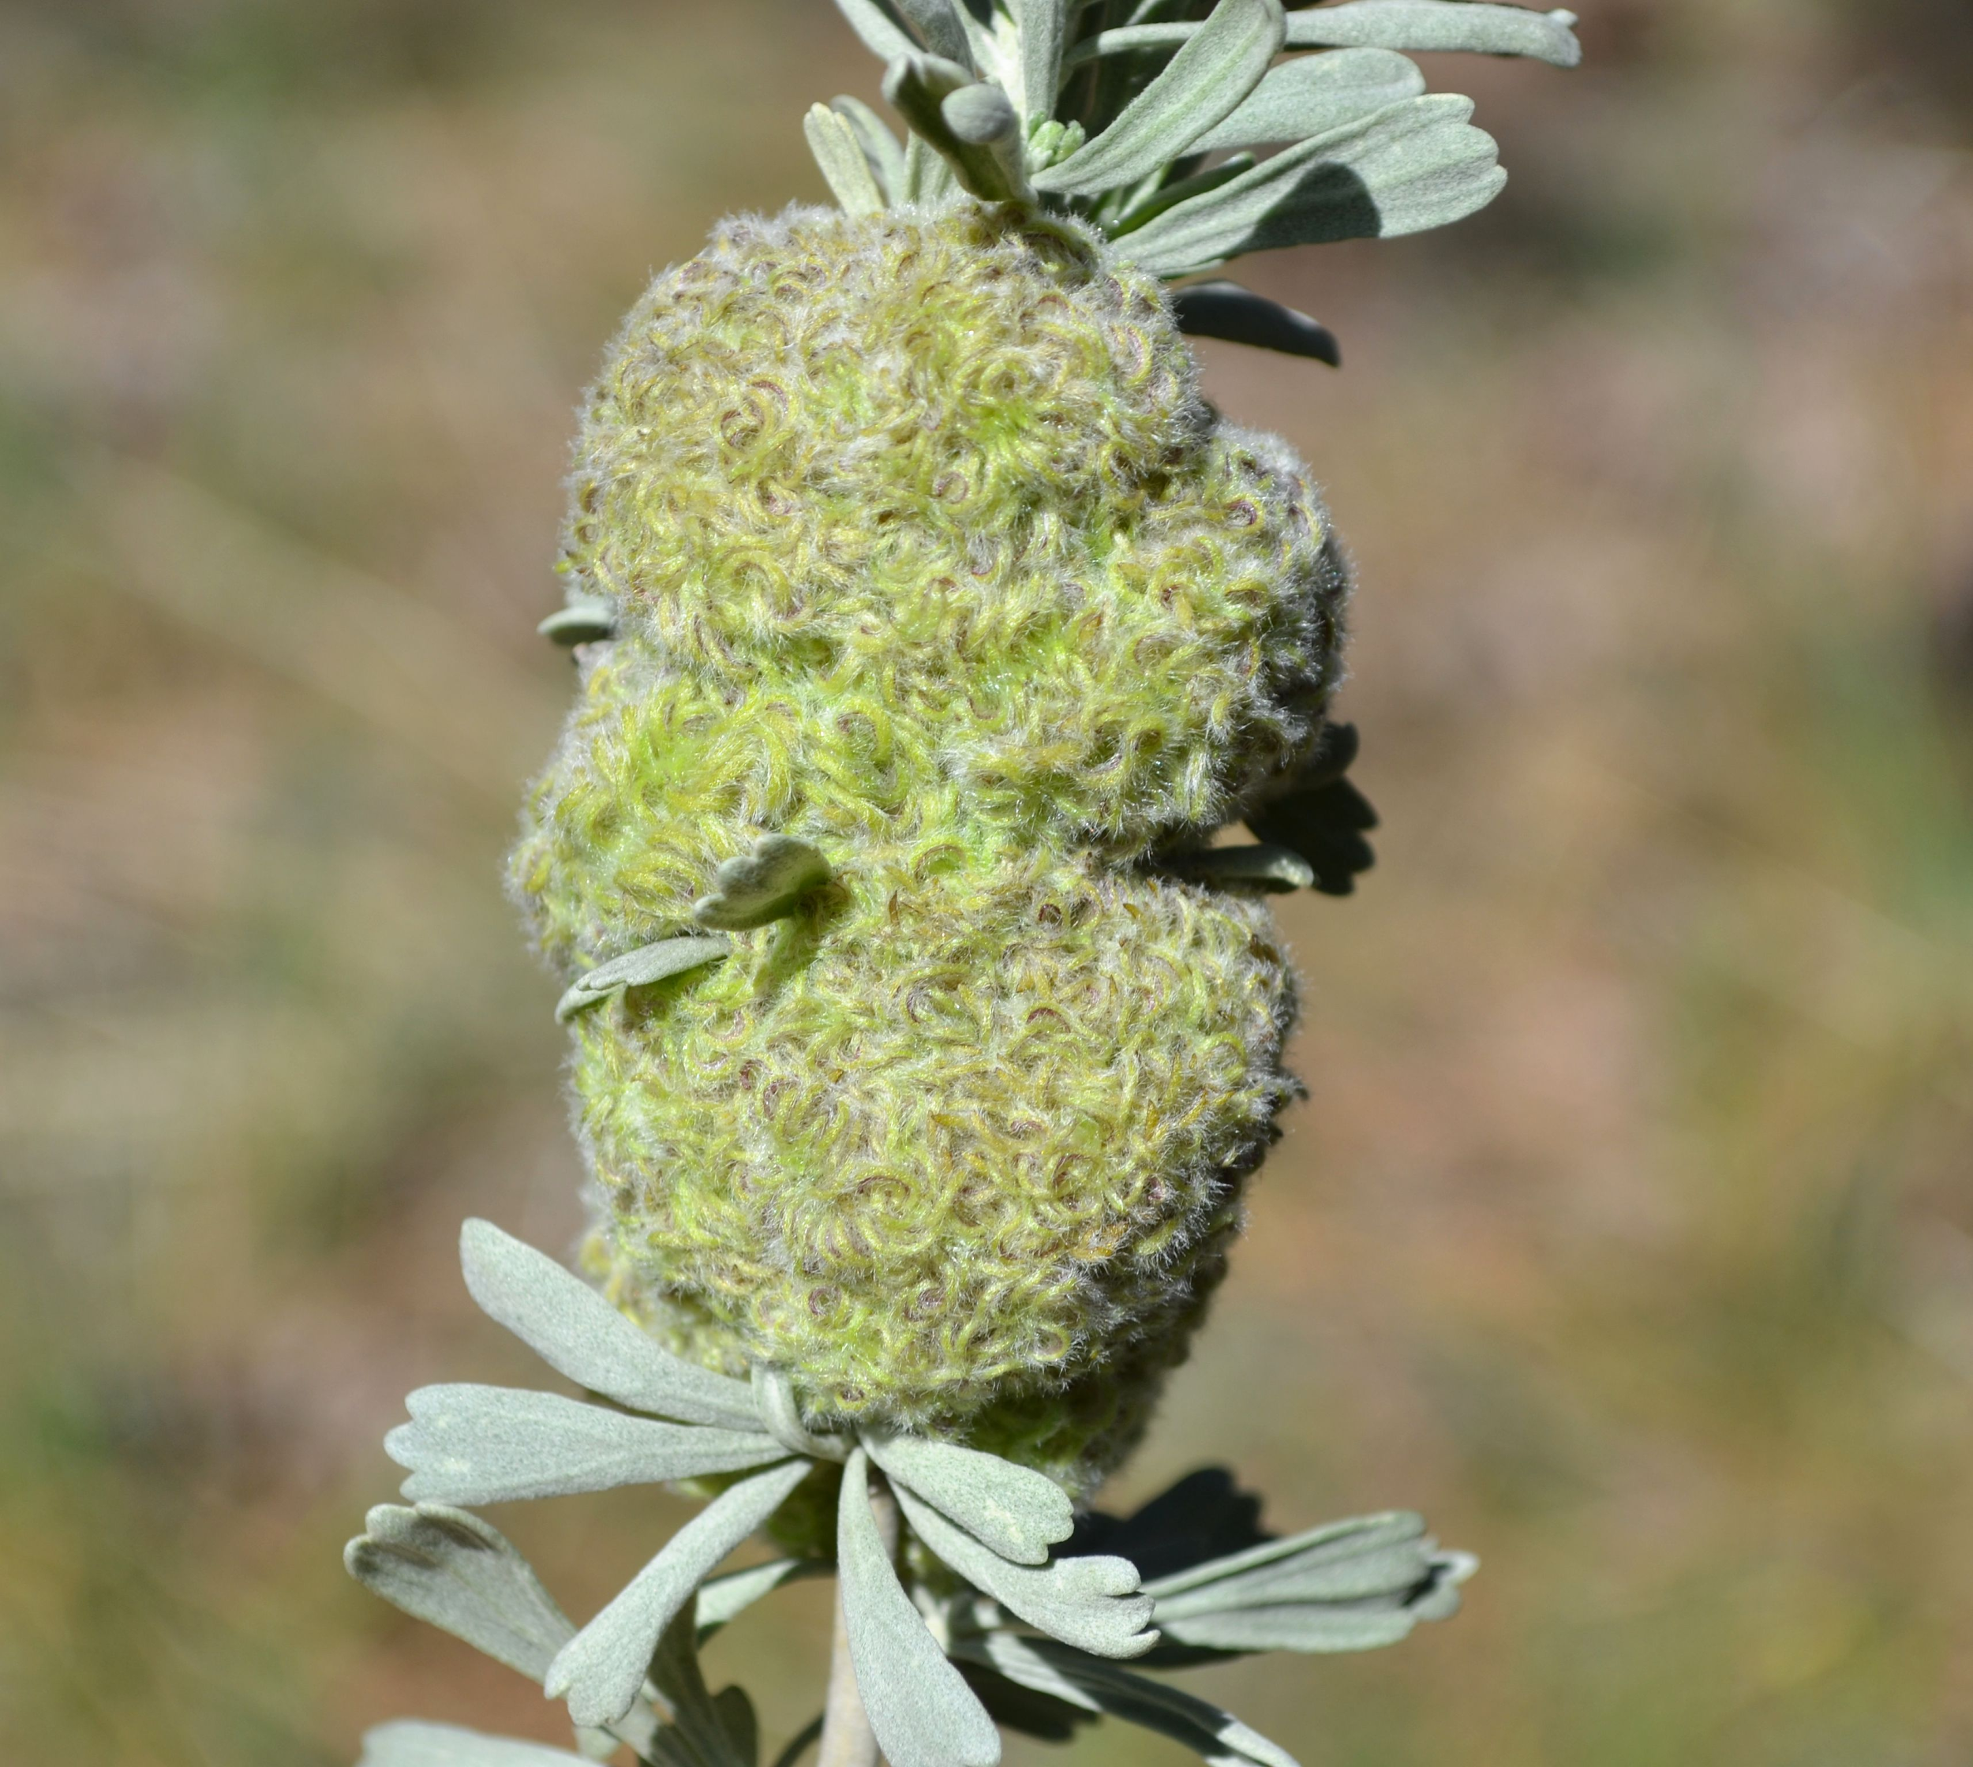

*How to count serpentine mines? It’s a confusing picture, but in that way more likely something that would be seen in the field! One of our gall gurus (Eric LoPresti) thinks this is probably two mines. He says, “the one that terminates at the top in a blotch and the one that terminates at the bottom center in a wider figure 8 - looks confusing since the bottom one doubled back, making a weird hanging trail. But you can tell that is a single mine, since there is no nearby really thin trail where it starts. The intermediate width mine on the right is odd - whether it was aborted/eaten or doubled back is not obvious to me, however, I suspect it is the latter, as I only see two really thin sections, both on the upper half, which indicates a start and a very small caterpillar.”

This can get confusing, but do your best. Each count doesn’t have to be exactly right; we should still be able to get a representative count of the distribution of damage & mine frequencies. If in doubt with these serpentine mines, standardize by counting only the blotchy/expanded mine ends; this will ignore (but in a consistent way) aborted or re-started mines.